**1. JAVASCRIPT Where To Write**

(হেড এর মধ্যে লেখা যায়।)

<!DOCTYPE html>

<html lang="en">

<head>

    <meta charset="UTF-8">

    <meta name="viewport" content="width=device-width, initial-scale=1.0">

    <title>Document</title>

    <script>

        let course="Master in javascript";

        let duration=10;

        console.log(course);

        console.log(duration);

    </script>

</head>

<body>

    <h1>Hellow</h1>

</body>

</html>

ctrl+shift+i

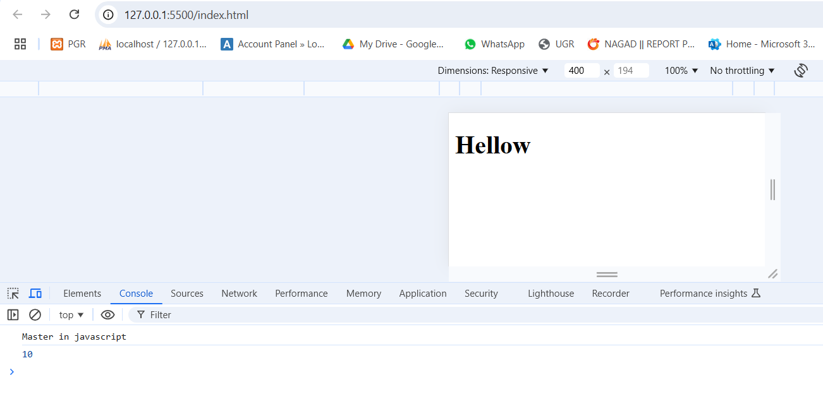

(বডি(body) এর মধ্যে লেখা যায়।)

<!DOCTYPE html>

<html lang="en">

<head>

    <meta charset="UTF-8">

    <meta name="viewport" content="width=device-width, initial-scale=1.0">

    <title>Document</title>

</head>

<body>

    <script>

        let course="Master in javascript";

        let duration=10;

        console.log(course);

        console.log(duration);

    </script>

    <h1>Hellow</h1>

</body>

</html>



(বডি(body) এর বাহিরে লেখা যায়। এটাই বেস্ট উপায়। কারণ এক্ষেত্রে বডি লোড হওয়ার পরে javascript লোড হয়।)

<!DOCTYPE html>

<html lang="en">

<head>

    <meta charset="UTF-8">

    <meta name="viewport" content="width=device-width, initial-scale=1.0">

    <title>Document</title>

</head>

<body>

    <h1>Hellow</h1>

</body>

<script>

    let course="Master in javascript";

    let duration=10;

    console.log(course);

    console.log(duration);

</script>

</html>



**2.Variable Declaration**

**var(পুরো Function এর মধ্যে access পাবে। reassign করা যায় একই ব্লক এ।লুপ এ ব্যবহার )**

* **Scope**: Function-scoped (accessible within the function or globally if declared outside a function).

**Let(ব্লক এর মধ্যে access পাবে। reassign করা যায় না একই ব্লক এ।লুপ এ ব্যবহার করার জন্য উপযুক্ত।)**

* **Scope**: Block-scoped (limited to the block, statement, or expression where it’s declared).

**Const(একবার assign হয়ে গেলে আর reassign করা যাবে না।)**

* **Scope**: Block-scoped, similar to let.
* **Immutability**: The value can’t be reassigned after initial assignment (though objects and arrays can still be modified).

১. var এর scope হচ্ছে Function scope(block এর মধ্যে declare করলেও সম্পূর্ণ function এ এ্যাক্সেস পাবে) আর let এর scope হচ্ছে Block scope(যে Block declare করা হবে শুধু সে ব্লক এ এ্যাক্সেস করা যাবে।).

<!DOCTYPE html>

<html lang="en">

<head>

    <meta charset="UTF-8">

    <meta name="viewport" content="width=device-width, initial-scale=1.0">

    <title>Document</title>

</head>

<body>

</body>

<script>

   function BlockTest(){

     var x="Function Scope";*// Function scope*

     let y="Block Scope";*// Block scope (limited to the function block)*

     if(true){

        var x1="Function Scope";

        let y1="Block Scope";

     }

     console.log(x);*//Accessible here Because Function Scoped*

     console.log(y);*//Accessible here (block-scoped in the function block)*

     console.log(x1);*//Accessible here Because Function Scope*

     console.log(y1);*//Error:y1 is accessible in only block only*

   }

   BlockTest();

</script>

</html>

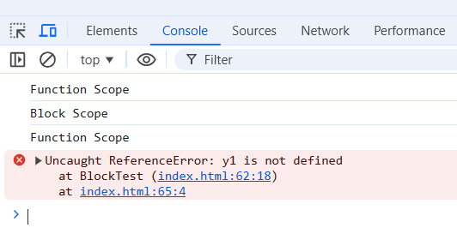

২.ReDeclaration করা যাবে var এ কিন্তু let এ ReDeclaration করা যাবে না।

<!DOCTYPE html>

<html lang="en">

<head>

    <meta charset="UTF-8">

    <meta name="viewport" content="width=device-width, initial-scale=1.0">

    <title>Document</title>

</head>

<body>

</body>

<script>

   function BlockTest(){

     var x="hi";

     var x="hellow";

     let y=1;

     let y=2;//Error here

   }

   BlockTest();

</script>

</html>

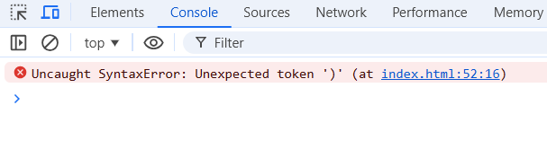

**3.ARRAY**

**Array তৈরি(create) করা :**

<!DOCTYPE html>

<html lang="en">

<head>

    <meta charset="UTF-8">

    <meta name="viewport" content="width=device-width, initial-scale=1.0">

    <title>Document</title>

</head>

<body>

</body>

<script>

*//Using Array Literals:*

    let fruits = ["apple", "banana", "cherry"];

*//Using the Array Constructor:*

    let numbers = new Array(1, 2, 3, 4, 5);

*//Creating an Empty Array:*

    let emptyArray = [];

*//Use indices to access elements. Remember, indexing starts at 0*

    let colors = ["red", "green", "blue"];

    console.log(colors[0]); *// "red"*

    console.log(colors[1]); *// "green"*

*//length: Returns the number of elements in an array*

    console.log(fruits.length); *// 3*

 </script>

</html>

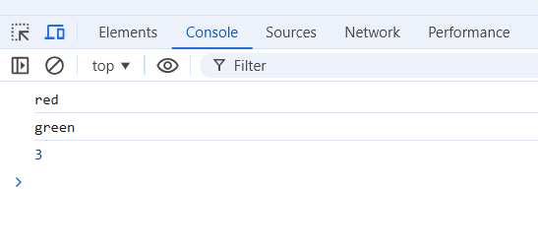

**Array Operation**

<!DOCTYPE html>

<html lang="en">

<head>

    <meta charset="UTF-8">

    <meta name="viewport" content="width=device-width, initial-scale=1.0">

    <title>Document</title>

</head>

<body>

</body>

<script>

*//push/add: element to array*

    let fruits = ["apple", "banana", "cherry"];

    fruits.push("orange");

    console.log(fruits);

*//pop:Removes the last element from the array*

    fruits.pop();

    console.log(fruits);

*//unshift: Adds an element to the beginning of the array.*

    fruits.unshift("kiwi");

    console.log(fruits);

*//shift: Removes the first element from the array.*

    fruits.shift();

    console.log(fruits);

 </script>

</html>

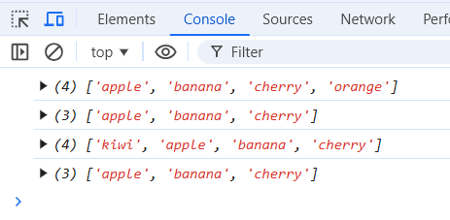

**4.Function**

**Syntax:**

function functionName(*parameters*) {

*// code to be executed*

}

<!DOCTYPE html>

<html lang="en">

<head>

    <meta charset="UTF-8">

    <meta name="viewport" content="width=device-width, initial-scale=1.0">

    <title>Document</title>

</head>

<body>

</body>

<script>

   function showName(*name*){

        console.log("Function name is "+*name*);

   }

   showName("Utsab");

 </script>

</html>

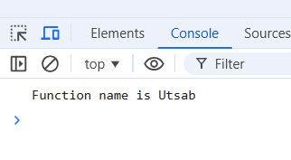

**Anonymous Function(যে ফাংশন এর নাম নাই)**

<!DOCTYPE html>

<html lang="en">

<head>

    <meta charset="UTF-8">

    <meta name="viewport" content="width=device-width, initial-scale=1.0">

    <title>Document</title>

</head>

<body>

</body>

<script>

   let greet=function(*name*){

        return "Hellow! "+*name*;

   }

   document.write(greet("Utsab"));

 </script>

</html>

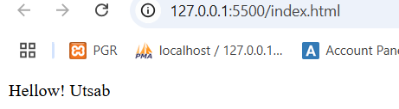

**Arrow Function**

<!DOCTYPE html>

<html lang="en">

<head>

    <meta charset="UTF-8">

    <meta name="viewport" content="width=device-width, initial-scale=1.0">

    <title>Document</title>

</head>

<body>

</body>

<script>

   (() => {

            alert("Hi dost");

        })();

 </script>

</html>

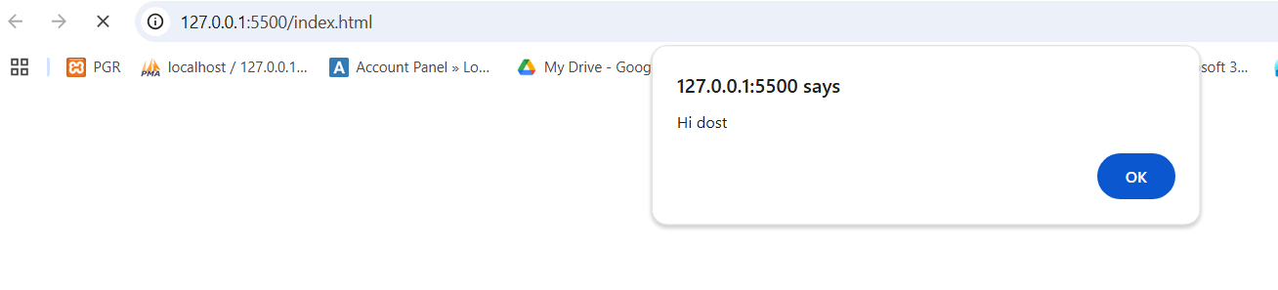

**ফাংশন থেকে VALUE RETURN করা:**

<!DOCTYPE html>

<html lang="en">

<head>

    <meta charset="UTF-8">

    <meta name="viewport" content="width=device-width, initial-scale=1.0">

    <title>Document</title>

</head>

<body>

</body>

<script>

   function multiply(*a*,*b*){

        return "Your sum is "+ *a*\**b*;

   }

   console.log(multiply(3,4));

 </script>

</html>

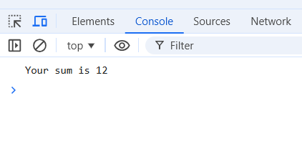

**Arrow Functions(**shorter syntax**)**

<!DOCTYPE html>

<html lang="en">

<head>

    <meta charset="UTF-8">

    <meta name="viewport" content="width=device-width, initial-scale=1.0">

    <title>Document</title>

</head>

<body>

</body>

<script>

   let sum_show=(*a*,*b*)=>{

    alert("Result is "+ (*a*+*b*));

   }

   sum_show(10,20);

 </script>

</html>

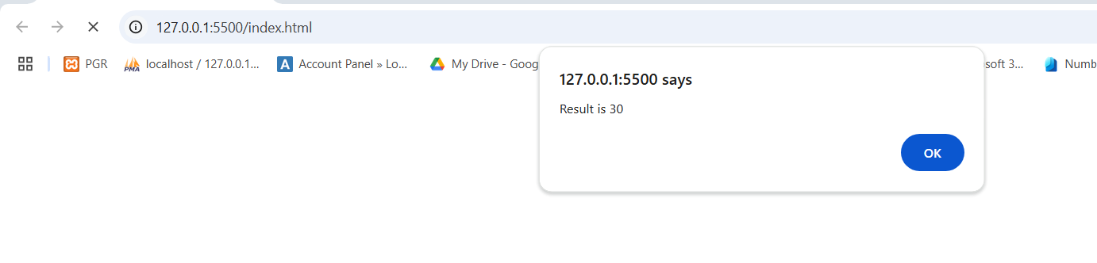

**5. display variable’s value**

**Variable এর জায়গায় value replace হওয়াকে বলে string interpolation**

**Using Concatenation with the + Operator**

<!DOCTYPE html>

<html lang="en">

<head>

    <meta charset="UTF-8">

    <meta name="viewport" content="width=device-width, initial-scale=1.0">

    <title>Document</title>

</head>

<body>

</body>

<script>

   let name='utsab';

   let age=20;

   let message="Name is "+name+" age is "+age;

   console.log(message);

 </script>

</html>

**Using Template Literals (ES6+)**

Single quotation(Backtrick symbol) এবং ${} ব্যবহার করতে হবে:

<!DOCTYPE html>

<html lang="en">

<head>

    <meta charset="UTF-8">

    <meta name="viewport" content="width=device-width, initial-scale=1.0">

    <title>Document</title>

</head>

<body>

</body>

<script>

   let name='utsab';

   let age=20;

   let message=`Name is ${name} age is ${age}`;

   console.log(message);

 </script>

</html>

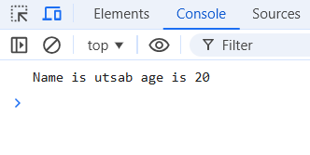

Link:

<https://eloquentjavascript.net/>

**6.Non Primitive Data Type**

**Object( class create করার মত:)**

<!DOCTYPE html>

<html lang="en">

<head>

    <meta charset="UTF-8">

    <meta name="viewport" content="width=device-width, initial-scale=1.0">

    <title>Document</title>

</head>

<body>

</body>

<script>

    let person={

        name : "utsab",

        age : 25,

        professtion : "Programmer",

        greet: function(){

            return "Hellow "+this.name;

        }

    };

    console.log(person.name);

    console.log(person.greet());

 </script>

</html>

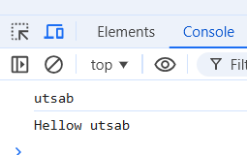

**Map**

**Set**

**Extension:  
Eslint(ভুল হলে সেটা ঠিক করে দেয়।)**

**Github Copilot(অটোম্যাটিক ‍suggestion দিবে।)**

**Branching Technique:**

**If-else**

<!DOCTYPE html>

<html lang="en">

<head>

    <meta charset="UTF-8">

    <meta name="viewport" content="width=device-width, initial-scale=1.0">

    <title>Document</title>

</head>

<body>

</body>

<script>

  let age=15;

  if(age>=18){

    document.write('You are eligible to vote');

  }else{

    document.write('You are not eligible to vote');

  }

 </script>

</html>

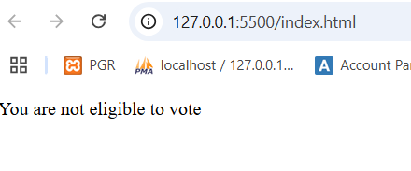

**SWITCH**

<!DOCTYPE html>

<html lang="en">

<head>

    <meta charset="UTF-8">

    <meta name="viewport" content="width=device-width, initial-scale=1.0">

    <title>Document</title>

</head>

<body>

</body>

<script>

    let mark=70;

    switch(mark/10){

        case 9:

        case 8:

            document.write('A+');

            break;

        case 7:

            document.write('A');

            break;

        default:

            document.write('Fail');

    }

 </script>

</html>

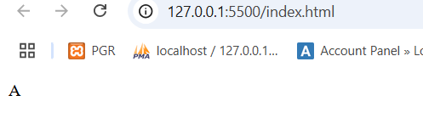

**Short-circuit operators**

**Logical AND (&&) - Conditional Execution**

<!DOCTYPE html>

<html lang="en">

<head>

    <meta charset="UTF-8">

    <meta name="viewport" content="width=device-width, initial-scale=1.0">

    <title>Document</title>

</head>

<body>

</body>

<script>

    let clicked=true;

    clicked && alert('Hi utsab');

 </script>

</html>

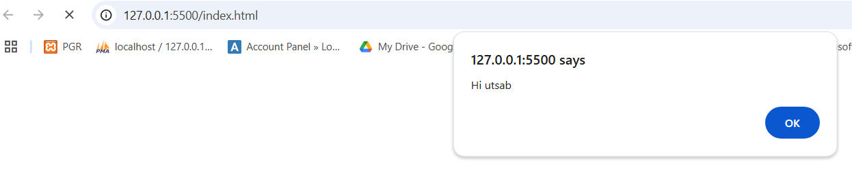

**Logical OR (||) - Default Value or Fallback**

<!DOCTYPE html>

<html lang="en">

<head>

    <meta charset="UTF-8">

    <meta name="viewport" content="width=device-width, initial-scale=1.0">

    <title>Document</title>

</head>

<body>

</body>

<script>

    let user = null;

    let defaultName = "Guest";

*// Using || to assign a default value*

    let name = user || defaultName;

    document.write(name); *// Output: "Guest"*

*// If user is not null, it would take the user's value*

    user = "Alice";

    name = user || defaultName;

    document.write(name); *// Output: "Alice"*

</script>

</html>

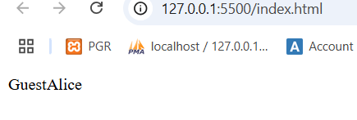

**Loop:**

**For / while / do-while**

<!DOCTYPE html>

<html lang="en">

<head>

    <meta charset="UTF-8">

    <meta name="viewport" content="width=device-width, initial-scale=1.0">

    <title>Document</title>

</head>

<body>

</body>

<script>

*// For loop*

    for (let i = 1; i <= 3; i++) {

        document.write(`For Loop ${i}<br>`);

    }

*// While loop*

    let j = 1;

    while (j <= 2) {

        document.write(`While Loop ${j}<br>`);

        j++;

    }

*// Do-while loop*

    let k = 1;

    do {

        document.write(`Do-while Loop ${k}<br>`);

        k++;

    } while (k <= 2);

</script>

</html>

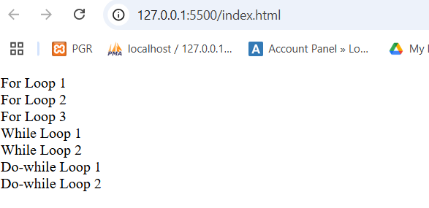

**for...of loop for...in loop forEach loop**

<!DOCTYPE html>

<html lang="en">

<head>

    <meta charset="UTF-8">

    <meta name="viewport" content="width=device-width, initial-scale=1.0">

    <title>Document</title>

</head>

<body>

</body>

<script>

*//The for...of loop is used to iterate over iterable objects like arrays or strings.*

   const fruits=["apple","mangoe","orange"];

   for (const single_fruit of fruits){

        document.write(single_fruit+'<br>');

   }

*//The for...in loop iterates over the keys of an object.*

   const object={name:"John",age:30,city:"New York"};

   for(const key in object){

        document.write(`key is ${key} value is ${obj[key]}<br>`);

   }

</script>

</html>

